

# American International University- Bangladesh (AIUB) Department of Computer Science

**Software Quality and Testing Spring 2021-2022**

## Project: Developing a Test Plan for Dhaka Subway Systems Automated Ticket Issuing System

### Final Term Project Report. Section: E

**Submitted By:**

|  |  |
| --- | --- |
| Name | ID |
| MINHAZUR RAHMAN | 19-39416-1 |
| NEEHAL ALAM | 19-39435-1 |
| JUAIRIA AKTER SETU | 19-39445-1 |
| MD. SAKIB HOSSAIN RIJON | 19-39460-1 |
| Sazid Al Farabi | 19-39478-1 |

1. **Test Plan Identifier:**

TicketIssueSys TST1.01

## References:

* 1. Requirement Specification.
  2. Functionalities Specification.
  3. Test Scenarios.

## Introduction:

A detailed document that catalogs and enumerates the test strategy, resources, schedule, estimations, and deadlines are referred to as a test plan. These criteria are required for completing a particular project within a given period. It is considered a template for conducting the tests required to ensure that the program is working properly, with test managers in charge. A test plan's main goal is to create documentation that explains how the tester will verify that the system operates as intended. What needs to be tested, how it will be tested, and who is accountable for testing should all be described precisely in the document.

This is a test plan developed on Dhaka Subway Systems Automated Ticket Issuing System. Subway tickets are sold by an automated ticketing system. Users choose a destination and provide a credit card number as well as their PIN. The subway ticket is issued, and the payment is debited to their credit card account. When the user presses the start button, a choice of possible destinations is displayed, along with a message asking the user to select a destination. Users are required to insert their credit card once the destination is selected. Once a destination has been selected, users are requested to insert their credit card. The authenticity of the card is verified, and the user is requested to enter the PIN. The ticket is issued once the payment is confirmed.

## Test items:

Below are items intended to test within the scope of this test plan.

* Monitors with touch screens as well as a keyboard interface
* Display the list of incoming trains and their destinations.
* Display the arrival and departure times, fare, expected travel time of the trains.
* Purchases of multiple tickets.
* Limiting the number of tickets purchased at the same time.
* Cancellation of a ticket prior to the purchase's final confirmation.
* Purchased ticket cancellation can be done by the administrator.
* Checks credit card transaction and validation
* Transaction using bill (taka) /coin
* Support navigation to the next step during the purchase of a ticket.
* Support previous navigation during the purchase of a ticket.
* Check ticket availability information.
* All information displayed via the web will be supported.
* Support account management of Dhaka Subway Systems.

## Software Risk Issues:

The software risk issues are mentioned below -

* Multiple ticket purchasing issue
* Coin/taka accepting issue
* Database security issue
* Navigation bar working issue
* Unavailability of real time information

## Features to be tested:

The features which will be tested are mentioned below-

* Touch screen monitor and keyboard interface
* List of trains and their arrivals, departure times, fares and all other information.
* Multiple ticket purchasing
* Number of tickets purchasing limitation
* Cancellation of ticket before final confirmation of purchase
* Cancellation of purchased ticket by the help of administrator
* Credit card transaction and validation working properly or not
* Support navigation bar during ticket purchase process
* Availability of tickets

## Features not to be tested:

Below are the features which are not required to be tested:

* Transaction using bill(taka) /coin
* All information displayed via the web.
* Account management of Dhaka Subway Systems.

## Approach:

### 8.1 Testing level:

The testing for the Dhaka Subway Systems Automated Ticket Issuing System will consists of Unit, Integration, System and Acceptance testing levels. However, with the budget constraints and maintaining time most testing will be done by the test lead with the development team's participation.

UNIT Testing will be written and executed by the software developers and will be approved by the development team leader. Each unit of code is validated against requirements of the unit by reviewing the code. The main objective is to test individual parts are working properly or not.

INTEGRATION Testing is basically performed by developers and executed by testers. The tester would test the scenarios and the developer would write the script for the test. Here the units of a program will be combined as a group.

SYSTEM Testing will be performed by the testing team. No specific test tools are available for this project. Programs will enter into the System test after all critical defects have been corrected.

ACCEPTANCE Testing will be performed by the actual end-users with the assistance of the test lead and development team leader.

## Item Pass/Fail criteria

The website will pass if the tester and users accept it and are satisfied with its performance. Otherwise, it will fail and the software will need to be checked again.

## Test Deliverables

* Test cases.
* Test plan.
* Bug reports and summaries.
* Execution logs.
* Error logs.

## Remaining test tasks

* Bug report.
* Create test cases.
* Create Integration test plan.
* Create System test plan.

## Environmental needs:

* Touch screen monitors
* Network Connectivity.
* Hardware configuration.
* Database Server.
* Operating System

## Responsibilities:

### Project Manager:

* Help define project scope, goals and deliverables.
* Manage budget.
* Define the tasks and resources which will be needed.
* Assign resources to the project.
* Make schedule and project timeline.
* Deliver the project in time.

### Test Lead:

* Defining the scope of testing within the context of each delivery.
* In the product and the Testing Team, using the right test measurements and metrics.
* Building up and leading the Testing Team to the success of project.
* The testing effort for any given engagement is planned, deployed, and managed.

### Quality Assurance Tester:

* Identifying client needs and ensuring that they are addressed.
* Setting customer service standards.
* Determining training needs.
* Writing technical reports.

### Developers:

* Writing and implementing efficient code.
* Assessing operational practicality.
* Deploying software tools, processes and metrics.
* Maintaining and upgrading existing systems.

## Schedule:

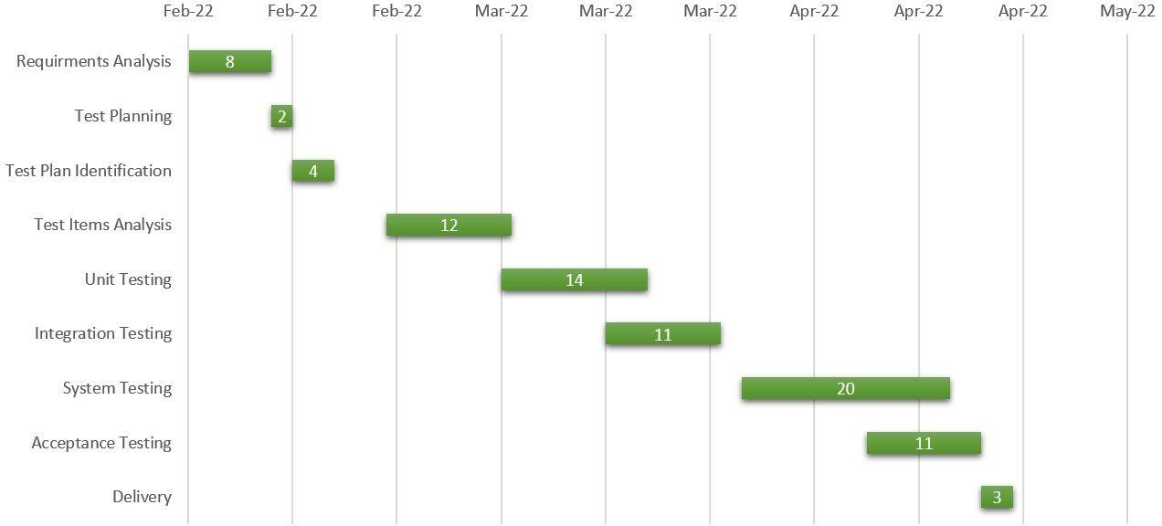

1. **Approvals:**

|  |  |  |  |  |
| --- | --- | --- | --- | --- |
| Name | Designation | Institute | Signature | Date |
| Sazid Al  Farabi | QA Tester | DatesoftInc | Sazid | 27-03-2022 |
| Sakib Hossen Rijon | Project Manager | Datesoft Inc | Rijon | 28-03-2022 |
| Minhazur  Rahman | Moderator | Datesoft Inc | Minhaz | 29-03-2022 |
| Neehal Alam | Developer | Datesoft Inc | Neehal | 27-3-2022 |
| Juairia Akter  Setu | Test Lead | Datesoft Inc | Setu | 27-03-2022 |

END